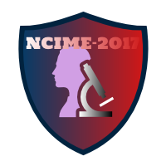

**Accommodation**

1) Free Accommodation will be provided to all Authors at campus. Twin sharing AC rooms will be provided.

2) Authors need to clearly specify regarding free accommodation at campus in the registration form.

3) Authors can also contact to Prof. A.G. Kamble (+91-9422984326) or Prof. S. V. Chavan (+91-9503898501) to confirm free accommodation.